No Excuses Writing List
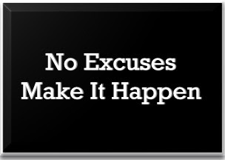

- Is your name and the date on it?

- Is it legible? (Can I read it?)

- No small i’s exist alone

- Common words are spelled correctly

- End of sentence punctuation

